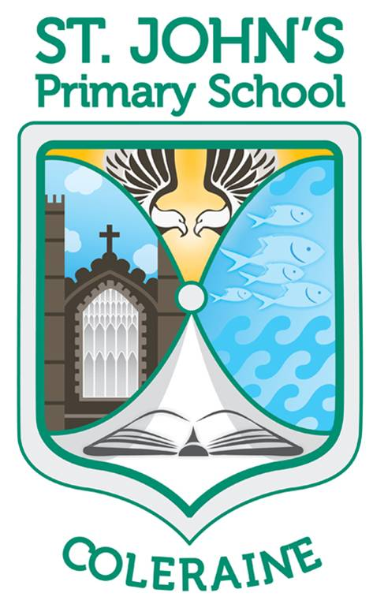St John’s Primary School

Hazelbank Road ● Coleraine ● BT51 3DX

Telephone: (028) 7034 4437

Principal: Mrs H McDonnell BA(Hons), PGCE, PQH(NI)

E-mail: cburns390@c2kni.net

[www.stjohnspscoleraine.com](http://www.stjohnspscoleraine.com) Twitter: @StJohnColeraine



Dear Parent/Guardian,

Please read the information below carefully. It is intended to help us all through the initial reopening of St John’s in a safe manner within the regulations set out by the Department of Education.

**KEY DATES:**

Thursday 20th & Friday 21st staff preparing classrooms.

Week Beginning Monday 24th-Thursday 27th August:

Yr2-7 children return to school on a reduced timetable to help them settle into their new school day and to give staff the opportunity to carry out the recommended cleaning in line with the guidance provided (see notes). **There will be induction meetings for Yr 1 children and their parents throughout this initial week. These parents will have received a separate letter.**

At this stage it is anticipated that Breakfast Club will commence on Monday 24th August to assist working parents (further details will be provided at a later date).

**Our school will be closed to our children on Friday 27th August and Monday 31st August**.

Tuesday 1st – Friday 4th September our school will be open to all children on a reduced timetable (see notes). **Year 1 children will follow guidance on page 3 of their Induction Booklet**.

Week Beginning 7th September- Normal school hours resume with staggered arrival and departure times (see notes). It is hoped that Afterschool’s will be available in some format from the 7th (more details to follow).

**New School Day**

From Monday 24th August we will need to stagger the arrival of our children to adhere to our return guidelines. Please note NO adult will be permitted onto the school grounds; staff will be on hand to help parents and children.

Years 5,6 & 7 should arrive at 8.45am and go directly to their classrooms.

Years 2, 3 & 4 should arrive at 9am and go directly to their classrooms (staff will help parents and children in the initial days). Year 2 children can use the infant gate.

*Please note: if siblings are included in both arrival times, the older child should arrive at 9am and assist the younger child.

Classes will operate in Social Bubbles. They will play and eat together during this initial period. For week beginning 24th August ALL children will need to bring a packed lunch and break in a plastic bag. No lunch boxes are permitted at this stage. Water bottles should be filled at home and clearly marked with your child’s name. At this initial point it is anticipated that there will be NO paid break available. Hot school meals will be available from Tuesday 1st September, please ensure your child has the correct change each day (£2.60).

**Collection of Children (Monday 24th August-Friday 4th September)**

For WB Monday 24th August and WB Tuesday 1st September children will go home after their lunches.

**Year 1 children will follow guidance on page 3 of their Induction Booklet**.

Years 2 & 3 can be collected from the infant and main gates at 12.15pm.

Years 4 & 5 can be collected from the main gates at 12.30pm.

Years 6 & 7 can be collected from the main gates at 12.45pm.

Again to assist this collection, younger siblings can wait in their classrooms until their older siblings are being collected.

Week Beginning 7th September.

Staggered arrivals as before.

**Collection of Children (from 7th September until further notice)**

**Year 1 children will follow guidance on page 3 of their Induction Booklet**.

Years 2 & 3: Home-time will be at 2pm.

Years 4 & 5: Home-time will be at 2.45pm.

Years 6 & 7: Home-time will be at 3pm.

At this point only younger children from Years 4 & 5 may wait for their older siblings.

**Uniforms/School Bags & Homework**

Pupils should wear their summer uniform to include their soft white polo shirt. Please ensure everything is labelled as usual. They should be encouraged to change out of their uniform as soon as they get home.

No school bags will be permitted for the first weeks of September. Children are not required to bring anything from home to school (except their coats and lunches).

During this initial period homework may be given. It will not be necessary for your children to return this work. However, teachers will revisit the homework collectively the following day. We will continue to use seesaw as a method of online learning as well as a means of communication. Reading will also be online to begin with.

**As with everything at the moment these arrangements are subject to change depending on COVID19.**

Best wishes for the remainder of your break,

**C Burns (Acting-Principal)**