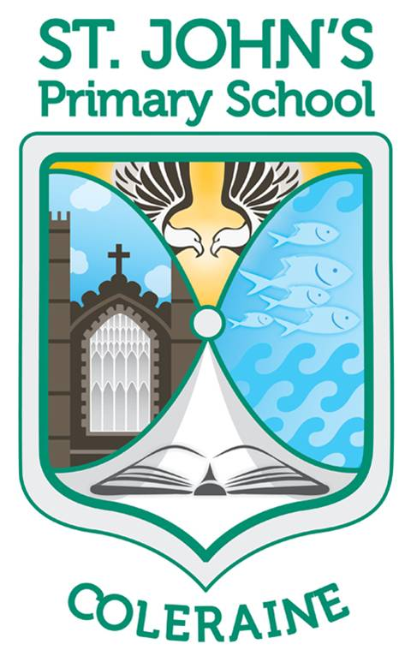

Allergy Awareness & Nut-Free Policy

St. John’s Primary School, Coleraine

Principal: Mrs H. McDonnell

Chairman of the Board of Governors: Mr L. McQuillan

August 2018
(updated August 2020)

Work hard Give everything a try Enjoy the rewards

This policy supports the overarching DENI and DHSSPS “Supporting Pupils with Medication Needs” (2008) policy and should be read in conjunction with Part IV of this policy – Management of Common Conditions). This policy should also be read in conjunction with the following school policies:
- Administration of Medication in Schools – May 2019
- First Aid – may 2019

Rationale:
‘The school’s ‘duty of care’ to pupils requires that all staff act in ‘loco parentis’ to
pupils entrusted to the school and any associated school related activities’. (Supporting Pupils with Medication needs, 2008)

We endeavour to ensure St. John’s Primary School is meeting the needs of pupils with allergies and is a nut-free zone. At St. John’s we aim to develop a positive partnership approach, with close cooperation between all stakeholders to ensure that a supportive environment for our pupils with medical needs is provided to enable them to fully participate in all school activities. At every opportunity we as a school, seek the wider school community’s cooperation in supporting the safety of all by acting in the best interests of all our pupils. Nuts and Peanuts are excluded from the school site based on the ingredient list of any food product. This policy is continually impressed upon everyone in our school community and especially in the classes of children who are directly impacted by allergies.

In response to the food sensitivities reported among current pupils we provide this policy. The immediate impact of a nut exposure to a child with a nut allergy can be life threatening and may require medical intervention or hospitalisation. The support of all school families and staff can make this a simple policy and relieve the worry of a possible nut allergy contact. For this reason, all staff members treat this as a ‘living’ policy, the content of which is impressed continuously onto all our children to ensure the message is not forgotten. The school will respond to other allergies as appropriate and in line with current care plans.

What is Anaphylaxis?
Anaphylaxis is an acute, severe allergic reaction requiring immediate medical
attention. It usually occurs within seconds or minutes of exposure to a certain
food or substance, but on rare occasions may happen after a few hours.

Common triggers include peanuts, tree nuts, sesame, eggs, cow’s milk, fish,
certain fruits such as kiwifruit, and also penicillin, latex and the venom of
stinging insects (such as bees, wasps or hornets).

The most severe form of allergic reaction is anaphylactic shock, when the
Blood pressure falls dramatically and the patient loses consciousness. Fortunately
this is rare among young children below teenage years. More commonly
among children there may be swelling in the throat, which can restrict the air
supply, or severe asthma. Any symptoms affecting the breathing are serious.

DENI and DHSSPS ‘Supporting Pupils with Medication Needs’ (2008)

Medicine and Control
Any, or all, of the following symptoms and signs may be present in an acute allergic reaction.
Antihistamine should be given at the first sign of an allergic reaction and the child closely observed. Antihistamine dose may need to be repeated if the patient vomits.
For a child who has asthma, if there is any sign of breathing difficulty then their reliever inhaler (usually blue) should be administered.

Minor reactions (needing oral antihistamine):
Feeling hot/flushing
Itching
“Nettle sting like” rash/welts/hives (urticaria)
Red, itchy watery eyes
Itchy, runny or congested nose or sneezing
Swelling: face, lips, eyes, hands
Tummy pain
Vomiting or diarrhoea
Metallic (funny) taste in the mouth

Even where mild symptoms are present the child should be watched carefully as they may be heralding the start of a more serious reaction. If the reaction continues to progress despite antihistamine and any of the following symptoms/signs are seen, then the EpiPen®/Anapen® should be administered into the muscle of the upper outer thigh and an ambulance called immediately.

Severe reactions (needing EpiPen/Anapen):
Difficult/nosy breathing, wheeze, breathlessness, chest tightness,
persistent cough
Difficulty talking, change in voice, hoarseness
Swelling, tightness, itchiness of the throat (feeling of ‘lump in
throat’)
Impaired circulation - pale clammy skin, blue around the lips
and mouth, decreased level of consciousness
Sense of impending doom (“I feel like I am going to die’)
Becoming pale/floppy
Collapse

If an EpiPen®/Anapen® is administered, the child should be kept lying down, with feet raised (e.g. on a chair) to assist circulation. They should transfer to hospital in this “head-down” position. Raising the patient’s head or assisting them to sit or stand up can result in an acute severe deterioration of the allergic reaction.
Occasionally, a second EpiPen®/Anapen® may be required if there has been no improvement in the child’s condition 5 to 10 mins after administering the first EpiPen/Anapen.

DENI and DHSSPS ‘Supporting Pupils with Medication Needs’ (2008)

Outcomes:
- Pupils with anaphylaxis will be safer and less likely to encounter substances that could initiate an attack.
- Teachers, pupils and parents will be more aware of the dangers for some pupils in relation to their allergy.
- Ideally, the incidence of anaphylactic attacks is minimised and averted altogether.

School practice to minimise risk to pupils with a known allergy:
- On enrolment, and annually thereafter, St. John’s will provide parents with the opportunity to update any medical information relating to their child’s allergies via a medical form. It is important that this is returned to the school as quickly as possible with all the relevant information included. For severe anaphylactics, this should include a care plan supplied by the medical profession. Parents should also update the class teacher and other relevant staff as the need arises.
- Where necessary, parents will supply all medication, along with two EpiPens (if required) in a secure and labelled see-through container to be kept at school. This medication will remain in a secure area of the general office. Individual arrangements may be made with the class teacher if applicable.
- Once the school has been made fully aware of the needs of pupils who have severe allergies, information about the child’s allergy, including a photograph of the child and a contact telephone number, is visibly displayed in the staffroom, general office, canteen and a copy is also available within each classroom.
- Continual advice around what should and should not be include in school lunches and snacks will take place on an ongoing basis in an effort to minimise the chance of anaphylactic children coming into contact with a nut allergen. Teachers will emphasis on a regular basis within the classroom about the need to avoid nut products and the weekly note will support this advice.
- Any birthday treats supplied for the class by a parent should be nut-free and be considerate of other allergies as appropriate.
- At all times, the sharing of food will be discouraged, especially at lunch and break-times. Staff supervising at lunch and break-time will remain vigilant to this issue.
- A laminated sign will be displayed in all classrooms and other areas as a reminder for parents and students.
- The canteen has also made a commitment to provide nut-free products.
- Each class teacher will accept and store alternative treats from parents of children who may suffer a reaction to shared birthday cakes/birthday treats. This has worked very well for all our children in the past.
- From an early stage, children will discuss the importance of keeping ourselves and our friends healthy. Through these discussions children will understand the need to think of others when making choices around snacks and treats.
- In the event of a school bun sale, every effort will be made to accommodate the needs of all children to ensure no child feels left out. Children and parents will be encouraged to provide nut free produce so all our children can enjoy these days.
- At St. John’s we firmly believe that the parent is in the best position possible to begin the education of their child with managing their allergy. The school, in conjunction with the child’s parents will work tirelessly to ensure that the child remains aware of their allergy and how it can be best managed so that they can fully participate in school life.
- Staff will be trained in the use of an EpiPen.
- EpiPens and medication will accompany students on excursions.

Useful websites:
www.anaphylaxis.org.uk
www.deni.gov.uk/support_with_medical_needs.pdf
www.safefood.eu/Nut-allergy 4

Links to other policies
Administration of medication

Monitoring and evaluation:
St. John’s Primary School will update this Policy in the light of any further guidance and legislation and review it annually.
On-going evaluation will ensure the effectiveness of the Policy.

PLEASE NOTE:
Whilst we can promote the allergy awareness and nut-free policy within the school community, its success is totally dependent on the co-operation of the parent body to ensure St. John’s is allergy aware and a nut-free zone.

